OXFAM AMERICA
THE RICE VALUE CHAIN IN HAITI: POLICY PROPOSAL
CARLOS FURCHE
30/07/2012

INTRODUCTION

The diagnostic of the Rice Value Chain in Haiti, and the policy proposal presented in this paper has been prepared as part of the OXFAM/AMERICA engagement in supporting small rice producers in the Artibonite Valley in Haiti.

The preparation of this paper is based on secondary data and documental revision, and also in field work in Haiti. The field work allowed a wide number of interviews with local authorities, Haitian professionals and experts in the agriculture sector.

The field work also included a visit to the Artibonite Valley, to take direct contact with farmers and local actors of the rice value chain, as well as professionals of public sector and NGO s working in the Region.

The work in Haiti was supported by the active participation of Mr. Luc Saint Ville and Mr. Paul Duret. Their generosity to share their deep acknowledgement of the Haitian reality has made this work possible.

Despite the fact that the ideas and proposals included in this paper, has been made under the responsibility of the author, they are part of the exchange of ideas and experiences between the author and the above mentioned distinguished Haitian professionals.

TABLE OF CONTENTS

INTRODUCTION…………………………………………………………………………………………………………2
- THE INTERNATIONAL RICE MARKET…………………..………………………………………………..4
  - Rice production and world marketing: Projections………………………………………..5
  - International prices: Trends……………………………………………………………………………8
  - Main rice exporters………………………………………………………………………………………10
  - International market prospects and significance for Haiti……………………………..11
- THE RICE VALUE CHAIN…………………………………………….…….…………………………………..11
  - Production, consumption and imports………………………………………………………….11
  - Other macroeconomic factors……………………………………………………………………….14
  - International trade distortions: The USA Farm Bill…………………………………………17
- ORGANIZATION OF THE VALUE CHAIN…………………………………………………………………18
  - Rice production: Main Issues…………………………………………………………………………18
  - Main factors of rice production stagnation……………………………………………………21
- POLICY PROPOSAL……………………………………………………………………………………………….24
  - Rice Policy Objectives……………………………………………………………………………….…..24
  - Strengthening basic infrastructure…………………………………………………………………25
  - Policies at primary production level……………………………………………………………….25
  - Policies to improve the coordination of the rice value chain……………………….….26
  - Price stabilization policies………………………………………………………………………………27
- ANALYSIS OF PRODUCTION REVENUES AND COSUMERS RICE PRICES…………………..30
  - Scenario of yield change…………………………………………………………………………………30
  - Scenario of tariff rate change…………………………………………………………………………31
  - Scenario considering changes in the international prices………………………………..33
  - Sensitivity analysis………………………………………………………………………………………...35
- CONCLUSIONS………………………………………………………………………………………………………38
.

- THE INTERNATIONAL RICE MARKET.

Due to the high level of openness of the Haitian economy, the economic performance of its main production chains, in this case rice, is directly related to the tendencies and evolution of the international markets.
It is a known fact that agricultural markets are affected by severe distortions, mainly caused by the subsidies and domestic support industrialized countries provide to farmers, as is the case in the United States and the European Union. Furthermore, some industrialized countries, such as Japan, in the Asian region, apply high rates of tariff protection to sensitive products such as rice.
Of course, the evolution of the international rice market is not different than that of other agricultural commodities, particularly cereals, for which there is a partial substitution effect both, regarding the use of land and in relation to consumption, as it occurs with wheat and with corn to a lesser extent.
International organizations and academic institutions agree that in the coming years it is expected that basic food prices will be kept at higher levels than the ones registered for most of the last decade; however, it is also anticipated that the short term instability and volatility affecting agricultural markets will remain, due to a set of structural reasons that are unlikely to change in the near future. Among the factors affecting price levels and agricultural market volatility are the following:
- The steady growing demand in emerging Asia, Africa and Latin America countries, as a result of population growth, rapid urbanization and increasing income levels that impact on aggregate demand for food.
- Climate change and its impact on agricultural production, due to the increasingly frequent occurrence of extreme climatic events, such as droughts or floods, which regularly affect agricultural production in various parts of the world.
- The gradual increase in biofuel production, causing the displacement of certain crops which are replaced by crops for energy production, such as ethanol. Biofuel production also impacts the price of some agricultural commodities such as sugar and especially corn.
- Economic instability, especially in industrialized countries, that are causing among other consequences high variability in the exchange rate, especially seen in the behavior of US$ Dollar and the EURO, which directly impacts the nominal level of prices of agricultural and non-agricultural commodities.
- An increase in speculative pressures associated with increased participation of future markets in the global food trade.
- The persistence of agricultural policies in industrialized countries that favor subsidies and domestic support measures to producers that traditionally have been a factor contributing to the instability of the markets.
Moreover, a recent publication of the OECD and FAO, adds that among the factors that will influence price levels, the smallest increase in production at rates below 2% annually, reflecting only modest increases in yields and productivity, which would add to a reduction in stock levels of grains and staple foods.
These general characteristics of agricultural markets are fully applicable to the rice market. To these, must be added that a particular feature of the international rice market is the fact that the volumes traded represent a small proportion of world production, precisely because in many countries, rice is an essential part of the population’s diet, and therefore is considered an essential element of its national food security strategies.

  - RICE PRODUCTION AND WORLD MARKETING: PROJECTIONS.
According to USDA figures, for 2012 it is estimated that about 32 million tons of rice will be traded in international markets, a figure that has remained with little change since 2005 when 29 million tons were traded.
Meanwhile, global production for this year is estimated to reach 732 million tons with a planted area of 165.1 million hectares, and a yield of 4.4 tons per ha. According to the FAO, there are no significant changes expected in these numbers over the short term. These figures show that the volume of rice traded on international markets does not reach 5% of the total global production.
This feature of the international rice market, dominated more by the requirements and needs of domestic demand in producer countries, is probably an additional factor of instability for international market prices, since it is a market dominated by a small number of countries with surplus. Still, as shown in the graph and tables presented bellow, both the planted area and global rice production experienced a gradual increase over the past 10 years. In 2000 399.4 milled million tons were produced compared to 457.9 milled million tons produced in 2010, representing an expansion of approximately 2% annually, which is consistent with the fact that the yields per hectare have remained virtually stagnant at about 4 ton/ha.
At the same time, the volume of rice traded in the international markets rose at a faster rate than the growth in production because in that period its volume increased from 24 million tons to just over 32 million tons, with 5% annual increases.
Another remarkable aspect of the figures presented is the significant decrease in volumes of stocks, which at the beginning of the period accounted for 37% of annual consumption, while in 2010 only reached 21%. The latter is consistent with the fact that the international rice market expanded faster than production, which has probably been offset by the more intensive use of stocks.

TABLE 1
 | Area |  | Production 2/ |  |  | Total | Ending | Stocks-to-
Year | harvested | Yield 1/ | Rough | Milled | Exports 3/ | use 4/ | stocks 5/ | use ratio 6/
 | Mill. Ha. | Mt/ha | ---Million metric tons---
2000/01 | 152.4 | 3.9 | 594.3 | 399.4 | 24.4 | 395.8 | 146.7 | 37.1
2001/02 | 151.4 | 3.9 | 594.7 | 399.7 | 27.8 | 413.5 | 132.9 | 32.1
2002/03 | 146.9 | 3.8 | 563.5 | 378.5 | 27.5 | 408.4 | 102.9 | 25.2
2003/04 | 149.3 | 3.9 | 585.4 | 392.5 | 27.3 | 413.9 | 81.5 | 19.7
2004/05 | 151.8 | 3.9 | 597.0 | 401.2 | 29.0 | 408.7 | 74.0 | 18.1
 |  |  | 622.9
2005/06 | 153.8 | 4.0 |  | 418.2 | 29.1 | 415.6 | 76.6 | 18.4
2006/07 | 154.6 | 4.1 | 626.2 | 420.0 | 31.9 | 421.5 | 75.1 | 17.8
2007/08 | 155.3 | 4.2 | 645.4 | 432.7 | 29.8 | 427.8 | 80.0 | 18.7
2008/09 | 157.9 | 4.2 | 669.2 | 447.5 | 29.3 | 436.0 | 91.5 | 21.0
2009/10 | 156.0 | 4.2 | 658.8 | 440.1 | 31.6 | 437.7 | 93.9 | 21.4
2010/11 | 158.1 | 4.3 | 676.6 | 451.6 | 31.0 | 448.4 | 97.0 | 21.6
2011/12 7/ | 159.9 | 4.3 | 685.5 | 457.9 | 32.2 | 458.7 | 96.2 | 21.0
1/ Yields are based on rough production. 2/ Production is expressed on both rough and milled basis; stocks, exports, and utilization are on
a milled basis. 3/ Exports are reported on a calendar year basis. For example, for 2005/06, exports are reported for calendar year 2006.
Trade data have been adjusted since July 1993 to exclude Intra-EC trade for the years 1980 to the present.
4/ For countries for which stock data are not available, utilization estimates represent apparent utilization,
I.e., they include annual stock level adjustments. 5/ Stocks data are based on an aggregate of different market years and should
Not to be construed to represent world stock levels at a fixed point in time. Stocks data are not available for all countries.
6/ Stocks-to-use represents the ratio of marketing year ending stocks to total utilization. 7/ Forecast as of May 11, 2011.
Source: USDA, Foreign Agricultural Service, Grain: World Markets and Trade, (Grain Circular).

Moreover, an analysis of projections for world cereal production appears to confirm, in the case of rice, reduced growth rates, estimating for 2020 a global production of 528 million tons, this is a little more than 10% higher than the 477 million tons currently produced.

TABLE 2
 |  |  | CEREALS: WORLD PRODUCTION FORECAST
 | 2012 | 2013 | 2014 | 2015 | 2016 | 2017 | 2018 | 2019 | 2020
Wheat | 684 863.59 | 694 235.92 | 706 297.32 | 711 942.08 | 719 417.05 | 724 918.02 | 732 057.61 | 739 261.84 | 745 899.31
Coarse grains | 1 191 669.90 | 1 213 390.98 | 1 222 145.35 | 1 241 085.58 | 1 246 665.56 | 1 270 747.20 | 1 285 224.80 | 1 310 252.09 | 1 320 710.96
Rice | 477 050.58 | 483 630.24 | 490 442.60 | 496 246.23 | 502 857.66 | 509 087.56 | 515 220.73 | 521 736.65 | 528 129.95
Source: OCDE-FAO. Agriculture Outlook. 2012-2020

  - INTERNATIONAL PRICES: TRENDS.
As noted, the trend analysis of rice prices is linked to the general characteristics of agricultural commodity markets, and has followed similar trends especially to those of other grains such as wheat, oats, barley and corn to a lesser extent.
The analysis of the developments in international rice prices shows a significant increase in prices in the years 2008-2010, and later a fall, but without returning to the levels of the beginning of the last decade. As noted, there is broad agreement that prices will remain high over the coming years, taking into account the structural factors that have driven prices up.
It is also worth noting that there are no significant differences in rice prices from Thailand, the world´s largest exporter, compared to the price of rice from the United States, whose price is about 5% lower. However, as discussed below, the relevant market for Haiti is the United States, where most of its imports come from.
In fact, projections published by the World Bank estimate for the year 2025 a minimum price, in nominal terms of US$ 480 per ton, which according to this estimate would amount to US$ 312 in real terms.

TABLE 3
INTERNATIONAL RICE PRICES (US $/Ton)
year | Long Grain (rough) | Long Grain (milled) | Thai 5% (parboiled) | Thai ( 15% broken)
2008 | 356 | 610 | 616 | 532
2009 | 316 | 506 | 544 | 472
2010 | 298 | 524 | 522 | 481
2011 | 338 | 559 | 588 | 574
Own Elaboration. Based on: Economic Research Services. USDA. Rice Outlook/RCS-June 2012

Meanwhile, FAO has a price index differentiated by rice quality, which allows a more accurate analysis. According to this index, the price has more than doubled in the last 10 years, moving from an index of 100 in 2004 to 161 in 2007 and 250 in 2011. The index shows a fall in the prices for high quality, aromatic and japonica, however, low quality rice registered a 1.1% increase.
TABLE 4
RICE PRICE INDEX
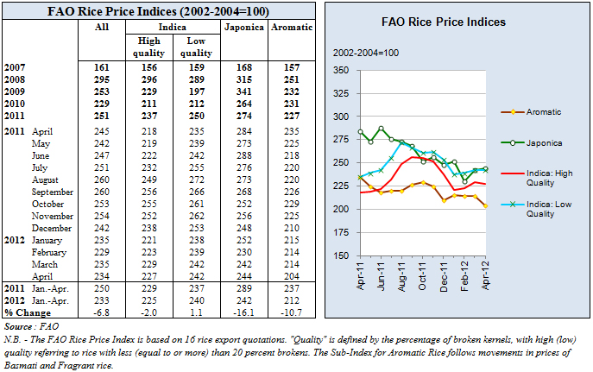
  - MAIN RICE EXPORTERS.

The main global rice exporters are located in the Asian region: Thailand, Vietnam, India and Pakistan. In the western hemisphere must be added the United States, Argentina, Uruguay and more recently, Brazil.

Nevertheless, rice exports are highly concentrated in a reduced number of countries. Thailand accounts for 39, 4% of world exports of processed rice, followed by Vietnam with 19, 6%. The United States accounts for 7, 2% of exports. In relation to rice paddy exports, the United States represents 90% of the total, followed by Paraguay and Brazil with figures of about 1%.

TABLE 5

WORLD LEADING RICE EXPORTERS.

Country | Exp (2008-2010  (1.000 ton) | %
Tailandia | 9.194 | 32.0
Vietnam | 5.600 | 19.5
Pakistán | 3.346 | 11.6
Unirte Status | 3.242 | 11.3
India | 2.569 | 8.9
World | 28.696 | 100.0
Source: Own Elaboration. Based on: USDA.ERS.October 2010. Cit in AmberWaves.Dec 2010

It is worth noting that among the top 10 exporters, according to this ranking, is also Uruguay in 7th place, with just over 1 million tons of annual exports. Other reports point out that Brazil has joined the countries that have recently managed to surpass 1 million tons of exports yearly. Yet, for Haiti the main supplier is the United States and to a lesser extent Uruguay, Argentina and more recently Brazil.

  - INTERNATIONAL MARKET PROSPECTS AND SIGNIFICANCE FOR HAITI.

From the point of view of prospects for the rice chain in Haiti, the analysis of international markets offers some useful conclusions for policy formulation:

- There is a broad consensus that the rice price level and other agricultural commodities will remain higher, probably similar to current levels.
- Regardless of the above, numerous studies and analyses point out that the volatility in food prices is a factor to be considered, raising the need for policy instruments to contribute to better risk management for prices and producer´s incomes.
- The projections of world rice production and trade shows an evolution without major changes for the coming years, with moderate expansion of production and consumption and also increasing global trade with rates comparable to those known in recent years.
- In relation to the main suppliers of the international market, the projections indicates that they will continue to be Asian countries, especially Thailand, Vietnam, India and Pakistan, with a significant presence of the United States and increasingly Brazil. With respect to Haiti, due to geographical proximity, lower transportation costs and quality adapted to the preferences of its consumers, it appears that its main supplier will continue to be The United States, with a possible increase in the participation of Brazil and as well as the neighboring Dominican Republic insofar that it has excess production.

- THE RICE VALUE CHAIN IN HAITI.

  - PRODUCTION, CONSUMPTION AND IMPORTS.

According to recent figures, rice is the main food item imported by Haiti, and it is also the most important staple for its population’s diet. According to information provided by the National Food Security Council rice imports during 2010 reached 381.212 tons, while domestic production in 2011 was equal to 77.551 tons.

According to these figures, total rice consumption in Haiti reaches a little less than 458.000 tons annually, of which 83% are imports, and 17% domestic production. Note that this dependence on imports has steadily increased in recent years as showed in imports evolution figures, due to the stagnation of domestic production for over two decades, with volumes of around 70.000 tons.

TABLE 6

HAITI RICE IMPORTS(Ton)

2001 | 2002 | 2003 | 2004 | 2005 | 2006 | 2007 | 2008 | 2009 | 2010
305.000 | 345.000 | 269.000 | 328.000 | 300.000 | 292.000 | 320.000 | 300.000 | 398.833 | 381.212
Source: National Food Security Council: Based on USDA.

Although there are imports of other cereals, mainly wheat and corn, rice purchases exhibit higher growth. In fact, imports have increased from 269.000 tons in 2003 to 381.212 tons in 2010, while domestic production has remained virtually stagnant for more than two decades.

The stagnation of domestic production is compounded by the rapid increase in domestic consumption, both due to population growth and changes in consumption patterns, which have favored the consumption of rice as the cheapest source of carbohydrates.

TABLE 7

HAITI: MAIN FOOD IMPORTS (2009)

Rank | Commodity | Quantity (tonnes) |  | Value (1000 $) |  | Unit value ($/tonne)
1 | Rice Milled | 297.935 |  | 174.961 |  | 587
2 | Wheat | 239.592 |  | 59.251 |  | 247
3 | Palm oil | 52.021 |  | 46.165 |  | 887
4 | Soybean oil | 45.025 |  | 44.000 |  | 977
5 | Sugar Raw Centrifugal | 95.776 |  | 42.137 |  | 440
6 | Milk Whole Evp | 23.638 |  | 33.108 |  | 1.401
7 | Chicken meat | 31.102 |  | 29.379 |  | 945
8 | Food Prep Nes | 2.308 |  | 23.502 |  | 10.183
9 | Sugar Refined | 39.515 |  | 18.693 |  | 473
10 | Food Prep,Flour,Malt Extract | 21.116 |  | 14.116 |  | 668
11 | Beans, dry | 23.304 |  | 13.953 |  | 599
12 | Garlic | 15.501 |  | 11.891 |  | 767
13 | Macaroni | 14.798 |  | 11.304 |  | 764
14 | Oil of vegetable origin, nes | 7.828 |  | 10.000 |  | 1.277
15 | Sugar Confectionery | 6.145 |  | 9.606 |  | 1.563
16 | Rice Husked | 31.845 |  | 9.500 |  | 298
17 | Flour of Maize | 20.485 |  | 9.250 |  | 452
18 | Paste of Tomatoes | 7.962 |  | 8.676 |  | 1.090
19 | Flour of Wheat | 22.437 |  | 8.300 |  | 370
20 | Milk Whole Dried | 1.567 |  | 7.165 |  | 4.572
SOURCE: FAOSTAT

In what refers to the origin of rice imports, it is clear that these come mainly from the United States, with volumes of around 300.000 tones. Haiti is now the second largest market for U.S. exports rice exports, representing 12% of their total rice exports.

TABLE 8

USA RICE EXPORTS: TOP 10 MAJOR MARKETS
(Long Grain Milled)

 | 2010/11 |  |  | 2009/10 |  |  | 2008/09
Rank | Country | Exports |  | Country | Exports |  | Country | Exports
 |  | 1,000 tons |  |  | 1,000 tons |  |  | 1,000 tons
1 | Mexico | 863.7 |  | Mexico | 843.9 |  | Mexico | 705.6
2 | Haiti | 310.0 |  | Japan | 361.4 |  | Japan | 335.6
3 | Japan | 305.1 |  | Haiti | 327.2 |  | Haiti | 275.9
4 | Canada | 227.6 |  | Turkey | 281.3 |  | Venezuela | 226.8
5 | Turkey | 200.7 |  | Venezuela | 243.7 |  | Canada | 217.8
6 | Venezuela | 147.3 |  | Canada | 227.5 |  | Saudi Arabia | 138.4
7 | Honduras | 135.7 |  | Iraq | 135.1 |  | Costa Rica | 126.9
8 | Nicaragua | 119.9 |  | Honduras | 125.4 |  | Iraq | 121.0
9 | Saudi Arabia | 117.5 |  | Saudi Arabia | 123.7 |  | Honduras | 115.1
10 | Iraq | 114.0 |  | Nicaragua | 113.0 |  | Nicaragua | 108.9
 | Sub-total | 2,541.5 |  | Sub-total | 2,782.2 |  | Sub-total | 2,372.0
 | Total exports | 4,018.6 |  | Total exports | 4,072.0 |  | Total exports | 3,460.5
Source: GAIN report. USDA.

  - OTHER MACROECONOMIC FACTORS.

The rapid growth of domestic rice consumption has been highlighted, which has replaced other traditional staples of the local diet, such as cassava and wheat products, while increased consumption has been supplied by imports, given the stagnation of domestic production.

In addition to the micro-level factors explained above, such as deficiencies in irrigation systems, poor infrastructure and inadequate basic services such as credit support, research and technological transfer, at least two other factors have significantly contributed to the current situation.

2.2.1. Low levels of tariff protection.

In 1995, the government adopted a set of economic reforms among which one of the most important was the reduction of tariffs on a significant group of agricultural products, including rice, whose tariff protection fell sharply from 50% to 3%. In fact, the tariff structure in Haiti considers three basic situations: i) Fully open without payment of duties; ii) Very low protection with a tariff of 3% and; iii) Moderate protection, with a tariff of 15%.

TABLE 9

TARIFF LEVEL FOR SELECTED PRODUCTS.

Product | 1995 | 1995-2009 | 2009-2011
Rice | 50% | 3% | 3%
Corn | 50% | 15% | 15%
Sorgho | nd | 0% | 15%
Wheat | nd | 0% | 4%
Wheat flour | 50% | 0% | 3.5%
Source: Food Security National Council. Haiti, May 2012.

Table 9 confirms that among the main cereals imported in Haiti, rice is the one exhibiting a lower level of tariff protection. Furthermore, it is interesting to note that recently high tariffs for corn, sorghum, wheat and wheat flour were set, although the latter at very low levels, probably due to the potential impact, as in the case of rice. on the price for consumers.

However, it is clear that there is a much lower level of protection in comparison to other countries in the region. In fact, in the Dominican Republic the tariff for rice imports is around 20%, while among CARICOM countries it averages 38%. Additionally, it should be noted that other countries in Latin America with higher levels of agricultural development than Haiti, such as Colombia, Peru and Ecuador have placed the rice in the so-called Sistema Andino de Franjas de Precios (Andean System of Price Band), establishing as a price stabilization mechanism, against distortions and instability in the price levels for products classified as sensitive.

2.2.2. EXCHANGE RATE CHANGES.

Another essential factor in the low level of protection that affects traded goods, is the level and evolution of the exchange rate between the Gourde and the currencies used in the international markets, which in the case of Haiti is primarily the U.S. dollar.

In fact, according to figures published by ECLAC the real Exchange rate has deteriorated significantly in recent years, which has accentuated the reduction in the alternative costs of imports of some agricultural commodities, especially rice, by the combined effect of almost eliminating tariffs and the exchange rate deterioration.

TABLE 10

HAITI: EVOLUTION OF INFLATION, NOMINAL AND REAL EXCHANGE RATE
(Index: 2006=100)

Year | Inflation | US $ ( nominal) | US $ (Real)
2006 | 100 | 100 | 100
2008 | 125 | 93 | 80
2010 | 135 | 98 | 77
2011 (Junio) | 148 | 97 | 72
SOURCE: Own Elaboration: Based on: ECLAC: Haití, Evolución Económica Durante 2010 y Perspectivas para 2011.Mexico, DF.2011.

This evolution of the exchange rate occurs in the context of the economic crisis aggravated by the 2010 earthquake, and is partly explained by the evolution of the U.S. dollar in international markets, and by two other endogenous factors to the Haitian economy: i) The steady flow of remittances from Haitian people based abroad, estimated to reach between US$ 1.500 million and US$ 2.000 million yearly, becoming the main source of foreign exchange currency available in the country, and, ii) The flow of international cooperation and foreign aid estimated to have reached in the period June-2010 to June-2011 US$ 3.812 million dollars.

Thus, despite the Haitian trade deficit that in 2010 it reached US$ 2.241 million, considering only the exchange of goods, it seems unlike that in the medium term there will be a more favorable evolution of the exchange rate for the tradable sectors.

    - LIBERALISATION AND INCREASE IN IMPORTS

There is no doubt that the combined effect of the deterioration of the exchange rate and the sharp decline in tariffs has significantly impacted local rice production, to the extent that producers have been exposed to international competition for which they were not prepared. This situation is compounded by international agricultural trade distortions. It has been noted that subsidies and domestic support given to rice producers in the United States reached US$ 434 million in 2009.

The figures on consumption trends, domestic production and increased imports show that imports soared after the tariff fell from 50% to 3%. The increase in international prices seems to have improved the relative situation of domestic producers, however not enough to offset the negative effects of the exchange rate and low tariffs already mentioned.

Despite the aforementioned, it is clear that the rice chain demonstrates a set of deficiencies at the level of primary production, processing and marketing, which were prior to the liberalization of the sector. Therefore, it would be a mistake to assume that the mere change in any of the macro factors, in this case the tariff protection level, could stimulate a rapid response to increased domestic production that would be able to replace imports competitively.

It is possible, as will be discussed later on, that the fragmentation of the production as well as the following links in the chain, in this case processing and marketing, and in contrast, the high concentration of importers, makes it difficult to effectively transfer the higher alternative costs of importing derived from a possible rise in tariffs, to the rice producers. Furthermore, a factor also to consider is the potential impact of increased tariffs on prices for consumers, which according to local authorities interviewed is seem as a potential source of social conflicts and political instability.

Considering the local context and the possible evolution of prices in the international market, the challenge lies in part in implementing policies to increase production and productivity at the primary level, and remedy deficiencies in the processing and marketing stages, and moreover to ensure stable conditions in terms of import costs, so as to ensure a medium-term horizon for local actors of the value chain, to carry forward investments to raise the competitiveness of the chain as a whole.

Stability in the medium-term is also a prerequisite for the deployment of public policies that require time for implementation, such as in the case of investments in basic infrastructure, irrigation and drainage.

  - International Trade Distortions: The USA Farm Bill.

It is well known the remaining of high distortions in agriculture international markets, due to the domestic support policies and export subsidies applied by developed and industrialized countries. The virtual stagnation on the DOHA round WTO negotiations does ‘not permit to be optimists about a short term modification of the current situation.

Regarding the rice value chain in Haiti, there are no doubts about the impact of the USA agriculture policy in the situation of local producers, as well has been pointed out in different studies and documents, since the main supplier for rice Haitian market are largely the USA.

Despite the fact that the rice international price is built attending several factors, like the production level in the most important producers and exporters, mainly Thailand, Viet Nam, Pakistan and India; the increase of production costs specially energy, fertilizers and oil derivate products; and even the evolution of international currencies rates like US Dollar and Euro, there are considerable expectative about the discussions related to the next Farm Bill in the United States, that ll be in force for the next five years.

In fact, during the last years the direct payments to rice producers in USA has reached over US $ 430 million, that means almost 20 times the total value of paddy rice produced in Haiti, and also represents about 20 times of the total agriculture aid provided by the USA to Haiti.

It looks probable that the new Farm Bill ll consider a gradual decoupling between direct payments and production level, and ll introduce subsidies to promote the intensive use of risk managements tools. However, it is too early to evaluate the impact of this new policy in the production level and exports surplus for commodities like rice. Anyway it seems reasonable to assume that distortions ll not be totally eliminated, and ll continue to affect poor countries like Haiti.

Taking into consideration this reality, the demand for increasing the USA aid to modernize the rice value chain in Haiti, increasing domestic production, straightening food security, and promoting higher income level and better quality of life for small rice producers in Haiti, is a way to mitigate negative impacts of their agriculture policy.

- ORGANIZATION OF THE VALUE CHAIN

The agricultural sector represents approximately 23% of the GDP in Haiti, and accounts for more than 50% of employment. Furthermore, in terms of production value, rice revenues reach a total of US$ 22, 4 million, which places the crop at number 11 among the most important in the country. This represents a production value very similar to corn, and potatoes, however it is much less than tropical crops such as mango and guava that occupy the top two spots in this ranking.

In any case, the rice chain’s relevance is not only based on its importance among the agricultural crops that structure Haitian agriculture, but also because it forms the basis of the Haitian diet, and at the same time is the main import for the food basket.

There are recent studies that analyze in detail the value chain of rice production, its main weaknesses and ways to address these deficiencies.

Additionally, for the research into the rice value chain, two prominent Haitian professionals have provided support, and an extensive series of interviews was conducted in Port of Prince and in the Artibonite Valley.
  - RICE PRODUCTION: MAIN ISSUES.

There is most likely some rice grown in all 10 of Haiti's departments (provinces), but according to the CNSA (the national food security agency), at least two thirds of the crop is produced in the Artibonite Valley. It has 35,000 hectares under irrigation and another 18,000 hectares that produce during the rainy season only.

There are two other key producing areas. The first is the Maribahoux Plain in the North-East Department, with about 10,000 improved hectares. Much of the investment in this zone comes from the Dominican Republic, which in most years also purchases most of the output. In 2010-2011, the Dominican Republic closed its border to Haitian rice, with negative effects on Maribahoux. The second area is the Tobeck Perimeter near Les Cayes in the South Department, with 2,000-3,000 irrigated hectares. Although the Perimeter only has a small area planted to rice, the infrastructure is reportedly in good condition.

It is estimated that the Artibonite irrigation system's full capacity during the rainy season is actually only around 30.000 hectares. This infrastructure was built 50 years ago,
and has not received significant investment for maintenance and repair, therefore, has serious deficiencies, especially at the level of secondary and tertiary distribution channels. The deficiencies of the water management system are also evident in the poor drainage systems. Hence a key aspect in the design of strategies for increasing productivity and implementing a national policy to promote rice production. must certainly be the improvement of the existing infrastructure.

National rice production has remained essentially steady since the 80´s, at around 70.000 tons, however according to figures released by CNSA, in the 2010-2011 seasons there was an increase that led local production to just over 77.000 tons.

The stagnation in production volumes is directly related to the virtually unchanged, for 20 years, low levels of productivity. Indeed, yields per hectare have remained around 2 tons per ha, for over two decades, without significant incorporation of genetic improvements, better land management and soil and cultural management technologies.

The fact that production takes place at a very small scale, on land with precarious ownership titles, and a tendency to subdivision and fragmentation due to the absence of employment alternatives for the younger generations, makes especially difficult the adoption of improved management technologies, as well as the mechanization of some productive processes, and the search for economies of scale in processing and marketing stages.

The inefficiencies at the level of primary production are reproduced in the following steps in the chain. Certainly, there is a great lack of infrastructure for drying and milling processes, which causes enormous post harvest losses that are absorbed entirely by the producers themselves.

To this must be added that supply chains are also fragmentized, with small producers selling their reduced volumes to small traders, that act directly as processors when they have milling installations, or that in turn deliver the rice to one of the numerous mills in the region, which in general are also inefficient.

From the institutional perspective, the main public agency present in the Artibonite Valley is the ODVA, conceived as a development agency to provide technical assistance, promoting the adoption of new technologies, supporting the development of cooperatives and producer organizations and providing basic services to support the productive development in the valley.

According to information collected in the field, the ODVA operates with a great shortage of personnel, because it has only 50% of the technicians that it requires to provide technical services to the valley producers, and does not have sufficient resources to develop investments in infrastructure improvement, particularly irrigation systems.

The Technical Cooperation Mission of the Government of Taiwan has significant presence in the Valley, and has focused on the adaptation and dissemination of seeds, with better genetic qualities and higher yields per hectare.

In addition, there has been longstanding work from some NGOs, among the most important being Oxfam England, Intermond and Oxfam America, which focus their work primarily on supporting the development of small producers organizations, in order to strengthen production and commercial management skills, and their representation and negotiation abilities with authorities and public agencies.

    - The Participation of Women in the Rice Value Chain.

It has become a frequent issue in the agriculture production in the world, the increasing participation of women at different levels of production chains. Recent publications place in 43 % of total agriculture vale production, the participation shared by women. Nevertheless, is noted a high heterogeneity between countries, crops requirements and even social level.

The case of Haiti looks similar to other less developed countries, with huge number of women head of family, and with a close involvement of the whole family group into the farm production, with the implementation of diversified surviving strategies, merging rural and non rural incomes and different uses of the family labor force possibilities.

Despite there is no data about women participation in rice production, it looks to be significant in different moments of the crop labor, including water management and harvest, and in general during the whole process after soil preparation and seeding.

In the other hand, the participation of women in the commercialization process seems to be still more important, both at level of trade exchange and price bargaining and also in the management of small mills and drying infrastructure.

Probably a specific research about the women participation in the rice value chain would be important to accurate the definition of particular policies oriented to them. However, it looks clear that ll be necessary to consider this factor in the definition of training programs, technical assistant and technology transference, to adapt their methodology and timing to maximize the possibilities for women participation.

    - Environmental Considerations.

Another issue to take into consideration, to define a program to increase domestic production and productivity of rice producers, should be the potential impact over the ecosystem, affected by the cultivation of rice without crop rotation practices, and with severe limitations in soil and water management, due to the poor conditions of the irrigation and drainage infrastructure.

The dissemination of better practices of land preparation and the identification of crop rotation alternatives shall be included in the technological packages to be promoted and eventually subsidized by the public policies.

An efficient way to promote a “natural resources conservation culture“might be to include this sort of considerations in the definition of the technical components of the System of Rice Intensification, identifying better practices for land preparation an also some possible and economically feasible alternatives to introduce crop rotation, to avoid the soil degradation risk associated to the intensive soil use in only one crop.

In this same vein, to promote and subsidize the use of fertilizers in a correct formula combination, adapted to the requirements of soil and crops, and also the use of good quality seeds, must be key elements of the technological package to be incentivized.

  - MAIN FACTORS OF RICE PRODUCTION STAGNATION

As noted, Haitian rice production has remained virtually stagnant for 25 years, while in the same period the consumption of rice increased several times. This has led the country from a situation of self-sufficiency to a large reliance on imports to meet domestic demand.

This productive stagnation is due to various causes, among which the most important are:

    - Primary Production Level

- The deficiencies of the irrigation and drainage infrastructure, which in the case of the Artibone Valley is affected by their age and lack of upgrading and maintenance, as well as the lack of investment to complete the network of secondary and tertiary channels.
- Lack of research to adopt and creating rice varieties with higher yield and good commercial value.
- Insufficient use of certified seeds by farmers and their organizations.
- Low levels of fertilizer use, and lack of detailed soil analyses to allow better identification of the most appropriated formulas for the soil conditions and requirements of rice production in the valley.
- Low adoption of technologies for planting preparation and crop management, as well as water and soil management.

    - Level of Processing and Transformation

- Lack of appropriate infrastructure for paddy rice drying.
- Fragmentation of installed capacity of milling, with proliferation of small traders and processors.
- Lack of adequate facilities at the level of small producers and their organizations for the collection and management of stocks.
- Separation of the chain between the level of primary production and producers and processors.
- Inefficient marketing channels due to lack of economies of scale and absence of adequate commercial information.

    - Institutional level

- Insufficient institutional capacity and resources from MARNDR and ODVA to deliver support services for production that responds to the needs of valley producers.
- Insufficient coverage of technical assistance and technology transfer.
- Lack of technical capacity to support the economic and commercial management of small farmers in the valley.
- Absence of channels and credit resources in line with programs that aim at modernizing production and increasing productivity.

    - International Trade.

- Wide and deep tariff liberalization, without adjustment periods for the local industry.
- Lack of tools to manage adequately the instability and volatility of international markets.
- Lack of regulatory framework to differentiate the entry of imported rice according to specific characteristics of quality and price.
- No regulations or phytosanitary controls for imported paddy rice.
- Insufficient border controls to limit access of low quality and cheap rice.

Based on this set of deficiencies and limitations described earlier some conclusions can be reached which in practice provide the rationale for proposing public policies that will be detailed bellow:

- There is no single political measure that in isolation would address the deficiencies affecting rice value chain in Haiti.
- The depth and extent of the problems require the formulation of policies, adoption of policy tools and resources allocation for the medium and long term.
- The disarticulation and fragmentation of the rice value chain, present as a key issue the search for better and efficient coordination mechanisms between the production and processing levels.
- The current level of international prices and the medium term projections, provide better conditions than in previous years for the establishment of a comprehensive policy for the rice sector in Haiti.
- The maintenance of a significant number of rice producers, who have resisted the adverse conditions resulting from the sharp tariff liberalization and unfavorable conditions of the international markets in preceding years, exhibits a resilience and adaptative capacity that should form the basis for the modernization process of the rice value chain in Haiti.

- The existence of long standing producer organizations may also be the basis for brokering support services and installation of processing and management capabilities.
- The development of specific technical experience and local expertise, can realistically justify programs that aim at rapidly increasing productivity and yields per ha.

- POLICY PROPOSAL

The formulation and implementation of a national policy for the rice chain should be associated to specific targets, in order to periodically assess progress and compliance goals.

  - Rice Policy Objetives.

    - Double, in a maximum period of 8 years, yields per ha, moving from the current 2 tons per hectare to 4 tons per ha.
    - Increase, over a 5 year period, 15% the irrigated surface, in order to reach a minimum coverage of 35.000 hectares with irrigation in the Artibonite Valley.
    - Achieve, over an 8 year period, a level of 50% of total self-sufficiency in rice consumption in Haiti. This includes increasing the annual production of milled rice equivalent, from 80.000 tons to 250.000 tons.
    - Double, in a 5 year period, the gross income obtained by small rice producers.
    - Promote better environmental practices, specially al level of soil and water management.

  - Strenghtening Basic Infrastructure.

    - Define a medium term investment program to improve irrigation and drainage infrastructure, especially at the secondary and tertiary levels. Of course, this forms the basis for other efforts to increase productivity and production, because it is a crop that depends on water availability and good management at the level of production units.

    - To establish an investment program through producer organizations in the valley, to develop facilities for rice drying and storage. This could have an important impact in reducing post harvest losses and an improvement in marketing channels, in favor of producers.

  - Policies at Primary Production Level.

    - Identify rice varieties with improved agronomic and commercial capacities in the Artibonite Valley; increase the capacity of certified seed production and promote its use among the small producers.

    - Increase the use of appropriate quantities of fertilizers and technical formulation tin accordance to the characteristics of different soils of the various zones and micro zones within the Arbonite Valley.

    - Promote the adoption of specific technological packages (integrating seeds, fertilizers, water and soil management), through direct subsidies to the small farmers.

    - Disseminate promising experiences such as the System of Rice Intensification (SRI), to rise paddy yields reducing costs and promoting better water and soil management.

    - Improve the coverage of public support services, especially technical assistance and technological transfer. This should involve not only an increase in resources for the recruitment of more professionals and technicians, but also a review of the methods and content used for technological modernization.

    - Access to appropriate credit and financing mechanisms for small producers, in terms of deadlines, payment conditions, interest rates etc.

  - Policies to Improve the Coordination of the Rice Chain.

    - Promote the installation of drying and milling infrastructure, according to current production and increases planned for the coming years. It was noted that this is one of the main deficiencies of rice production and several analysis suggest the need to correct it.

To increase milling capacity, both, from a technological point of view and in terms of scale for effective management of the product, would facilitate the following benefits:

- Get better conversion factor from paddy rice to milled rice, which currently does not reach 60%.
- Improve product standardization, facilitating its marketing.
- Decrease post harvest losses, which currently exceed 30%.
- Operate as a liaison mechanism between the demands and needs of the market and producers, delivering appropriate signals in respect to prices, quality and commercial properties more accepted by consumers.
- Act as an efficient mechanism for providing and channeling services to producers, especially with regard to technical assistance and economic management.
- Open the possibility for developing Supplier Programs, in form of guaranteed contracts with producers.
- Promote the establishment of Management Centers, specialized in supporting small producers in the economic management of the production process.

The installation of new milling capabilities can be developed under various formulas whose evaluation should be conducted in depth. Possible options include the following:

- Establishment of Joint Ventures between public sector, for example ODVA and private investors interested in investing in this field and settling in the valley.
- Facilitate the provision of modern drying and milling facilities through favourable and soft loans, or grant contributions, to cooperatives and producer organizations in the valley.
- Establish, through direct public investment, drying and milling facilities, by a specialized agency capable of economic and commercial management.

The installation of drying capabilities means significant investments which require not only adequate financing conditions, but especially two basic conditions:

- Stability in the alternative import costs, so as to reduce the risk of any sharp decreases in international prices that could affect the balance of local suppliers vs. imported suppliers.
- The adoption of a national rice policy to deliver credible signals about the priority given to increasing production and local productivity.

  - Price Stabilization Policies.

The tariff reduction brought by the Government of Haiti in the mid-nineties, created a rapid and abrupt change to the conditions under which domestic production was developed. Numerous studies and assumptions point to this as one of the fundamental causes of the rice production stagnation in Haiti and its growing dependence on imports.

Notwithstanding that the tariffs certainly are an important factor, their modification does not seem to be in any way sufficient to change the competitiveness of rice in Haiti, due to the numerous and clear problems at primary and intermediate level of the value chain.

In addition, it is evident the high social and political sensitivity to the possibility of an increase in rice prices for consumers, because it is main staple food of Haitians, making it very unlikely that the authorities endorse significant modifications to the current tariff level.

However, there is also recognition that the current levels of liberalization increase the risks arising from volatile international markets and are a clear disincentive to promote investments in support of gaining production and productivity and modernizing the various links of the value chain.

Based on these elements, the establishment of a price stabilization mechanism is proposed, capable of maintaining prices in an acceptable range for producers and consumers, and predictable in a medium term horizon, for the different actors in the chain. There are different international experiences aimed at price stabilization, even though the most commonly used are;

- Establishment of Price Bands. This is a mechanism that establishes a price range within which tariffs are fixed that determines the Alternative Cost to Import.

The establishment of this system, which determines a floor and a ceiling price for imports, based on international prices taking into account the relevant markets for the product, requires an efficient and systematic updated system of prices and market information.

Given the limitations to receive regular and updated information and the fact that the ad valorem tariff is only 3%, which would make irrelevant the possibility of tariff reductions if the international price reached very high levels, this option does not seem advisable.

- Determination of Minimum Entry Prices

This mechanism is also widely used, with different variations, in several countries. This is indeed the mechanism by which the European Union seeks to stabilize over time the price conditions with which producers operate in various areas of agricultural production.

As in the aforementioned mechanism, it aims to establish a minimum price for imports. When the CIF import price does not reach a minimum price, a mechanism operates for increasing the tariff rate to reach the minimum price of admission.

Given the institutional and market conditions that exist in Haiti, this seems to be the mechanism that best suits its needs.

    - Operation of Price Stabilization Mechanism.

- Identification of relevant markets in question.

Given the fact that at least 80% of the rice imports come from U.S. and that the imports from other countries such as Uruguay, Argentina or Brazil, enter at prices below the U.S. it is proposed that the prices of U.S long-grain rice should be taken as the market of reference.

- Determination of the Price level to operate the mechanism.

Several opinions expressed in Haiti, indicate that the international price FOB of US$ 650/ton, determine a final import price of around US$ 900/ton. It includes insurance and transport costs, plus taxes and financial costs, carrying the alternative import cost to around US$ 1.000 per ton.

If it is deemed that this is an appropriate level for the actors in the rice chain, especially when producers reach better levels of productivity, the mechanism should operate by compensating via tariffs, the imports that do not reach the CIF price of admission defined as Entry Price.
- Adustamente Frequency.

Considering the volatility of international prices, it seems reasonable that the Minimum Entry Price be periodically reviewed and that based on this the tariffs be determined. Therefore it is proposed to conduct a review every six months, at predetermined dates.

To establish the minimum entry level price, we propose the creation of a Technical Committee, with representatives from the Ministry of Agriculture, Ministry of Commerce, producer organizations, importers and professionals who know the rice sector.

Definitely, the proposed mechanism should operate based on a standard application formula as follows:

EP= CIF+LD+X

In addition to the relative simplicity of its operation, this mechanism would not change significantly the current level of prices already assumed by consumers. Furthermore, by making a periodic revision leaves open the possibility of collecting the trends of international markets.

This is ultimately a mechanism that should act as a safeguard against a possible an eventual sharp fall in international prices which will further deteriorate the situation of producers.

At the same time, its adoption should give credibility to the national rice policy, ensuring a stable and predictable horizon in the medium term to investors and actors of the chain.

5. ANALYSIS OF PRODUCER REVENUES AND CONSUMER RICE PRICES

5.1. Scenario of Yield Change.

For the baseline scenario two crop yields are considered: i) A low yield of 1.75 ton/ha and; ii) A high yield of 2.5 ton/ha. For both, have been considered three different scenarios of yield increment: i) 30% increment; ii) 50% increment and; iii) f 100% increment. For each scenario, income per ha was simulated for which the details are outlined in the following tables:

Detail | Current | Yield +30% | Yield +50% | Yield +100%
Rice yield (ton/ha) | 1,75 | 2,3 | 2,6 | 3,5
Total Income Rice (US/ha) | 963 | 1.251 | 1.444 | 1.925

Detail | Current | Yield +30% | Yield +50% | Yield +100%
Rice yield (ton/ha) | 2,5 | 3,3 | 3,8 | 5,0
Total Income Rice Season (US/ha) | 1.375 | 1.788 | 2.063 | 2.750

The following graph shows the variation in producer earnings per season for the different yield change scenarios:

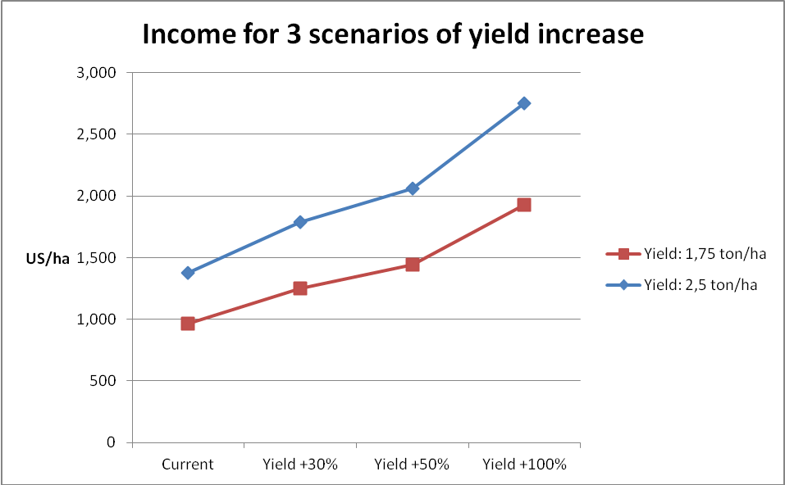

5.2. Scenario of Tariff Rate Change.

Considering two tariff rate change scenarios for rice: i) with the current rate of 3%; ii) with an increment up to 10%; iii) with a ceiling of 15%.

The calculation of the final price or opportunity cost to local rice is detailed in the following table, where from a FOB price of 550 US/ha, we reach a price of 1.007 US/ha:

Detail | Current
FOB | 550
Insurance (2%) | 11
Sea freight | 289
CIF | 850
CIF + Tariff (3%) | 875,5
VT (5%) | 43,8
VAT (10%) | 87,6
Final price | 1.007

The 3 tariff rate scenarios and the final price simulated for both, rice producer and consumer, can be seen in the following table:

Tariff Rate Scenario | Tariff 3% | Tariff 10% | Tariff 15%
Producer price rice (US/ton) | 550 | 587 | 614
Consumer price rice (US/ton) | 1.050 | 1.121 | 1.172

The following chart details the changes in producer and consumer prices for the 3 rates:

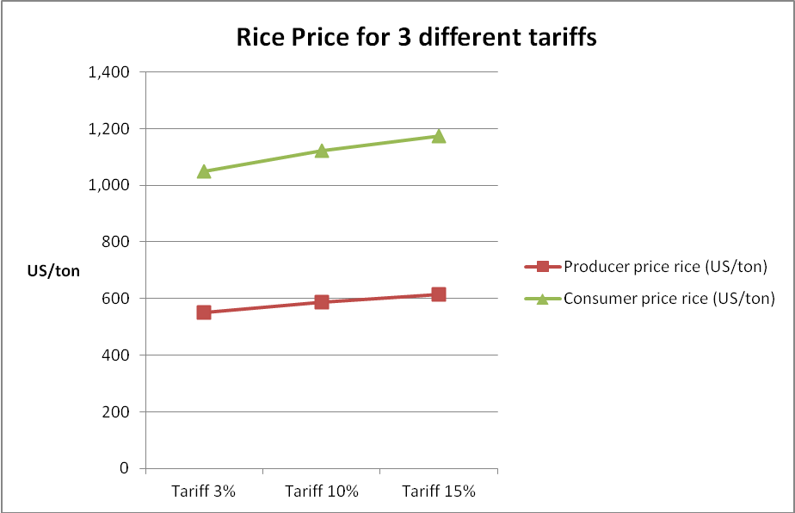

The table below, for 2 types of rice yields, presents the simulated income, in US $, considering the tariff scenarios:

Rice Yield (US/ha) | Tariff 3% | Tariff 10% | Tariff 15%
Yield: 1.75 ton/ha | 963 | 1.028 | 1.075
Yield: 2.5 ton/ha | 1.375 | 1.468 | 1.535

5.3. Scenario Considering Changes in the International Price.

The impacts analysis of international price changes over domestic prices and producer income is presented. To do this has been considered four different hypothetical situations: i) Increment of 10%; ii) Increment of 20%; iii) Detriment of 15% and; Decrement of 20% respectively. The five scenarios of tariff rate change and the final price for both simulated price for producer and consumer can be seen on the following table:

Impact Measurement | Current | FOB Price +10% | FOB Price +20% | FOB Price  - 15% | - 20%
Rice producer price (US/ton) | 550 | 586 | 623 | 496 | 477
Rice consumer price (US/ton) | 1.050 | 1.119 | 1.189 | 946 | 911

The following graph shows the change in the producer price of rice for the five modeled scenario:

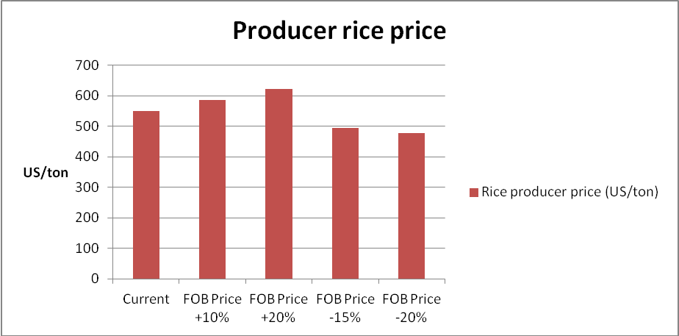

Considering the impact of income (US $ per ha) on producers, the following table details the income changes for two yields in the four scenarios of international rice price changes:
Rice Yield | Current | FOB price +10% | FOB price +20% | FOB price -15% | FOB price -20%
Yield: 1,75 ton/ha | 963 | 1.026 | 1.090 | 867 | 835
Yield: 2,5 ton/ha | 1.375 | 1.466 | 1.557 | 1.239 | 1.194

Graphically it is summarized as follows:

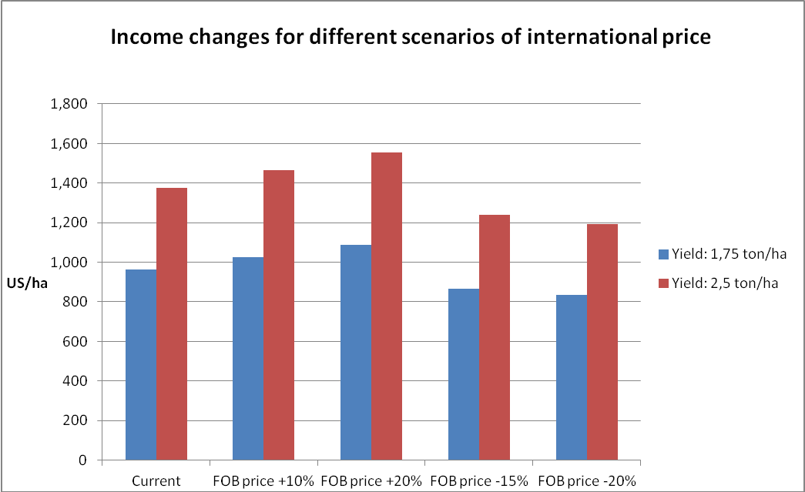

5.4. Sensitivity Analysis.

Using a Montecarlo simulation process, we performed a sensitivity analysis of producer’s sales revenue for 10.000 different scenarios joining different variables: Yield; Tariff and international price variations.

Tornado charts sensitivity analysis show the rankings of the input variables (yield, international prices and tariff) on the output variable (producer income and consumer price).
It will be analyzed the impact of the three input dependent variables on the output variables by tornado analysis using mapped values of regression

The mapped values ​​are a transformation of the beta coefficient of the regression to real magnitude values. The coefficient of this analysis indicates the number of standard deviations in the output variable that will change given a change of one standard deviation in the input variable (assuming all other variables remain constant). The values ​​in the X axis of this chart tornado type quantify the change in output variable due to +1 standard deviation change in each input variable.
The graph shows the values ​​of the coefficients of each variable ranked according to their greatest impact on the output variable. In other words, it shows the sensitivity of the output variable to input variables

The following chart shows the tornado analysis for the seasonal producer revenue:

The graph interpretation shows that yield is the most important variable in improving the income to the producer, followed by an increase in international prices, the variable rate being less relevant when an increase in revenues per season to each producer.
According to an analysis of the elasticity income-yield it can be seen a proportional elasticity (value 1), there is a proportional increase in income compared to an increase in crop yield. The international price-income elasticity is 0.66; it is more inelastic than the income-yield elasticity. The income-tariff elasticity is even lower (more inelastic than the last) with a value of 0.03, where increases in the tariff generate low revenue growth.

These results reinforce the results of sensitivity analysis, where the producer's income is more sensitive to variations in yield than the other variables studied.

Considering the consumer rice price, the following graph shows a sensitivity analysis to changes in international prices and import tariffs:

According to the tornado chart, the consumer price is more sensitive to variations in international prices of rice to changes in the tariff on imports. This is seen in the increasing value of the coefficient for the international price for the tariff.

Considering elasticity, the consumer-international price elasticity has a value of 0.66, while the consumer price-tariff elasticity is 0.03. That is, the price more elastic to consumers from international price movements than to variations in the rate, which is consistent with the previous analysis.

The graph above shows more impact, in consumers price level, to changes in international prices than in changes. In summary, results shows consistently high income elasticity for changes in productivity, and lower elasticity for changes in tariff level, if it is considered 15% as a ceiling limit.

In the other hand, international price increasing variations seems to have high potential impact over consumer’s price. On the contrary, decreasing price variations could have significant impact on producer’s income. Considering that price volatility will continue to be a risk for agriculture commodities in the next years, the adoption of some kind of price stabilization mechanism should result into a good option for both, consumers and producers.

Model Assumptions:
• It is considered a current FOB price of 550 US/ton
• It is considered a CIF price of 850 US/ton
• In order to have a CIF price, it took an insurance of 2% (standard) and a fixed cost of sea freight of 289 US/ton
• The tariff on the CIF value is 3% (current)
• On the CIF value + tariff rates are calculated stamp taxes of 5% and a sales tax of 10% (TCA)
Imports are also subject to a 5% stamp tax (FV) and a 10% turnover
tax (TCA).
• The current producer price considered was 550 U.S. /ton
• we assumed a consumer price of 1050 U.S. /ton
• It was considered two current yields, a 1.75 ton/ha and other greater than 2.5 ton/ha.
6. CONCLUSIONS
The exercise of sensitivity, to evaluate the impact of different policy options over the rice value chain, can rise some useful conclusions for the selection of options that would have a positive impact on producer income, and at the same time would not be especially burdensome for consumers:
  - Increments in productivity, due to the increase in yields per hectare, are far away, creating a greater and faster impact on the producer’s income. Certainly, the greatest impact is obtained with a largest proportional increase in yields; however, even assuming more modest increases (30%), the impact continue being relevant.

It has been remarked that, to make possible fast and significant increase in productivity it is required to implement a set of policy tools, among which the most important are:

- Develop an investment program aimed at improving irrigation and drainage infrastructure, in order to allow a more efficient management of water resources, appropriate to the needs of the different stages of cultivation.

- Promote the adoption of a technology package of high impact on productivity. Without prejudice of a more detailed definition of the components of this technology package, to be done by specialists in the rice cultivation, it is clear that this must be based on improving genetic resources (seeds), micro and macro nutrients availability (fertilizers) and soil and water management.

- Consider subsidies to promote the technological innovation package might be an efficient way to accelerate the adoption process, and also a rapid way to get impact in producer’s income.

- The cost of driving a technology package of this nature will be determined by the number of farmers to be assisted by the program and the proportion of subsidy to be considered to promote its adoption. However, it must be noted that the establishment of a subsidy is a necessary condition for the success of this policy.

- Additionally, the capabilities of ODVA should be extended, increasing resources for extension and technology transfer in such a way to expedite the process of technological upgrading and increased productivity.

- The impulse to forms of association, collecting and expanding existing experiences, is also a factor to be incorporated to achieve a greater impact on policies designed to increase productivity.

  - The tariff rate increases in different scenarios presented, this is, increasing 10% and 15%, shows a lesser significant impact on producers income.
Furthermore, although any increase in rates does not show a dramatic modification on price to be paid by consumers, the cost-benefit, economic and probably political and social, does not make it advisable to provide such measures.
However, the reality of the international markets, affected by distortions arising from subsidies applied by industrialized countries and short-term volatility in the price level, will require stabilization instruments that allow to have a predictable price horizon in the medium term.
Therefore, the adoption of a price stabilization mechanism, as proposed in this document, is a necessary tool to enhance the viability of the policies of technological modernization and increased productivity.

Government transfers to the rice sector in the USA, in 2010, reached U.S. $ 400 million. See: Marc Cohen: National ou Diri Diri Miami?: Food Agriculture, and US-Haiti Relations. Oxfam America, April 2012. Meanwhile, the tariff for imports of rice in Japan can reach as high as 1,000%.
In this regard, a recent paper by Eugenio Diaz Bonilla and Juan Francisco Ron: Food Security Price Volatility and Trade, published by ICTSD (International Centre for Trade and Sustainable Development), Issue Paper No. 28. 2010. Notes that expected production and food trade continued to be affected by both long-term trends, which point to an increase in the price level or at least to the maintenance of current levels, such as trends and short-term cycles, which will likely show high volatility and instability arising in various structural factors, such as those listed below in the text.
See: IFPRI: Major Food Policy in 2011. Shenggen Fan. Chapter 1.
According to recent figures, nearly 40% of U.S. corn production is oriented to the production of biofuels, which explains its current price level, and affects quite directly in the price of other cereals.: See: IFPRI: 2011 Global Food Policy Report. Chapter 2. Maximo Torero. Riding the Rollercoaster.
OCDE-FAO: Agriculture Outlook. 2011. Summary Chapter
USDA. FAS.GRAIN Report.
Paddy Rice: Estimations of FAO: FAO, Rice Market Monitor. April 2012. Volume XV, Issue N 2 Source: Rice Market Monitor. FAO, April 2012
Milled rice
It refers to paddy rice, Thai, 5% broken grain. World Bank. Commodity Price Forecast. Up dated June 2012.
Importantly, recent reports indicate that Brazil for the first time over one million tons of exports, which places him among the 8 major world exporters. Of that total, 66,000 tons were exported to Haiti. View: Oriza: Global Market Place Information. June 2012.
IFPRI: Food Prices: Riding the Rollercoaster. Op Cit.
Average annual exports during the period.
ORIZA.Op Cit
Information provided by Mr. Gary Pierre Mathieu, Food Security Coordinator, during an interview held in Port au Prince on May 24, 2012.
This is milled in both cases
See: GAIN. Global Agriculture Information Network. USDA. Nov. 2010
According to that GAIN report, it is estimated that from 2010 there was an increase in domestic production due to the positive impact of subsidy on fertilizers and better irrigation. This would bring local production to between 80,000 and 90,000 tons in 2011.
According to GAIN, Global Agriculture Information Network, USDA, about 85% of Haitian rice imports are provided for USA exporters.
OXFAM: Planting Now. Oxfam Briefing Paper. October 2011.
Note that the bound by Haiti to the WTO, in the case of rice, is 50%. Furthermore, Haiti has reserved rice list of exceptions to negotiate joining CARICOM.
ECLAC: Haiti: Economic Developments in 2010 and Prospects for 2011. Mexico, DF.2011
The World Bank estimated the value of remittances for 2010 at U.S. $ 1,571 million: See: World Bank. Migration and Remittances. Factbook.2011.
ECLAC. Op Cit
OXFAM Briefing Paper: Planting Now. October 2010.
Local authorities interviewed, including Mr. Minister of Trade and Industry and a former Prime Minister, expressed his reluctance to raise rates that may exaggerate the base product of the diet, especially low-income Haitian population.
David C Wilcock. Op Cit; OXFAM: Planting Now. Op Cit
OXFAM. Planting Now. Op Cit
ECLAC. Ibid
Source: FAOSTAT. In: Wilcook and Franco: Table 2. Ibid
See: Haiti Rice Value Chain Assessment: Rapid Diagnosis and Implications for Program Design. David C Wilcook.and Franco Jean Pierre. Oxfam America. March 2011. Draft, Final Version.
This work has had the collaboration and technical support of Mr. Paul Duret and Mr. Luc Saintville. Haitians Agriculture Engineers with great knowledge and experience in Haitian agriculture and rice production.
CNSA. Ibid. David Wolcock and Franco Jean Pierre have estimated the Artibonite Production accounts for at least 75% of total national production.
Wilcok David and Franco Jean Pierre. Ibid
Ibid.
David Wilcok David and Franco Jean Pierre. Ibid
There is no sufficient information to know if it is only an isolated issue, or if it might show a new trend
Some technical specialists estimate in 160.000 the number of people working in the rice value chain. See: Association Nationale des Agro-Profesionnels Haitiens. Une Politique Nationale Rizicole. * Siynthese). Roosevelt Saint Dic. Mars 2008.
Organization for the Development of Artibonite Valley. Institution depending of the Ministry of Agriculture, Natural Resources and Rural Development of Haiti.
Interview with the Director of ODVA. Artibonite, May 30th.
The variety of more rapid diffusion is called TS 10
The Role of Women in Agriculture. Cheryl Doss and SOFA team: FAO, ESA working paper N 11-02. March 2011.
During the field work in Artibonite it was evident the direct participation of women in the agriculture activities and also in the commercialization process.
This Identification causes of the situation of rice production is based on interviews in Port au Prince with politicians and technical specialists as well as review of documents and secondary information. See: David Winlock, and Franco Jean Pierre. Ibid; One Politique Nationale Rizicole. Ibid.; Planting Now. Oxfam America
One of the main problems of the rice value chain is the lack of coordination between primary production and processing of level. The absence of mills in a position to contribute to order the production process and act as a vehicle for channeling support services to production is a limitation to the modernization of the rice chain should be tackled as a priority. Feasibility studies are available regarding the possibility of installing modern capabilities and larger scale for more efficient drying and processing of rice in the Artibonite Valley. View jobs in December Saint Roosevelt, developed for the MARNDR of Haiti.
It relates in particular to the border with the Dominican Republic
Several studies suggest that this is a possible and realistic goal to achieve, even in a shorter period of time. View: Roosevelt Sain December Ibid. and David Wilcock. Ibid. Similarly, the Minister of Agriculture said that the objective of the Ministry is double the national production of rice in a period of 10 years.
It is possible that this goal can be modified to incorporate other geographic areas with irrigation and drainage potential of being expanded and improved.
There are at least two varieties in widespread use. TC 10 and Sheila. Some works such as Saint Roosevelt recommend investigating the creation of new varieties to include the best features of both. Other experiences to support small-scale production show that the partial or total subsidy to the use of quality seeds can be an efficient mechanism of technological change.
Producers and their organizations stand out as a very positive and high-impact, subsidizing fertilizer prices has been implemented at various times. In this regard, if any resources, public and external cooperation, it would be advisable to define subsidies comprehensive technology package, including seeds, fertilizers, soil and water management.
At the moment, some subsidies to fertilizers price is being applied. International experience show good impact of subsidizing technological innovation, using direct mechanism to reach the farmers. The amount and detailed ways to apply the subsidies should be defined by the MARNDR.
The system of Rice Intensification (RSI) has been succefully promoted among small producers in some Asian countries, and has started to be disseminated in Haiti by OXFAM and the USAID cooperation programs, also with promising results.
There are numerous experiences that encourage formalization and modernization of small producers through the promotion of “contract farming”. For this, the establishment of specific programs, linking small farmers, under formal modalities with agro industry has proved as an effective tool.
There is a total absence of systematic information on production costs, prices of inputs and the final product and overall economic management and commercial production process.
In this regard, a major importer of rice, Mr Kenneth Michel, Executive Director of Haiti International Evenings we expressed interest and willingness to develop local capacity investments to install drying and milling.
The latter option is highly recommended if you decide to act through the establishment of a state purchasing power, able to influence and regulate their action through the domestic market for rice.
In the interview with Mr. Kenneth Michel, said that estimated an investment of approximately $ 6 million to install an infrastructure capable of processing approximately 60,000 tons of paddy rice.
This was emphasized in several interviews with Haitian authorities and politicians. Interviews with Mr Minister of Trade and Industry, and Mr a former Prime Minister of the country as well as with officials of international missions.
This is, with some variations, the mechanism that operated in Chile for a long period of time, for some sensitive products like wheat, sugar and oilseeds, and still operates even on imports of wheat. It is also the mechanism used by member countries of the Andean Community, Bolivia, Peru, Ecuador and Colombia, seeking to protect their most sensitive agricultural sector, including rice. Meanwhile, the Dominican Republic also uses a similar mechanism for rice and other products.
When prices fall below the price set, it triggers a compensatory mechanism by way of additional tariffs up to the floor previously defined, thereby protecting the producer’s situation. By contrast, when international prices exceed the established ceiling, operates a mechanism to reduce or eliminate the ad valorem tariff to allow prices do not exceed that ceiling, and thus protect the interests of consumers.
While the special plight of Haiti suggests the existence of a considerable scope for trade policy, it should be recalled that the fact of maintaining a WTO bound tariff of 50%, and the exclusion of rice from its accession Caricom, virtually exclude the possibility that the adoption of a mechanism of this nature is challenged before the WTO, or negatively appreciated by CARICOM.
According to information collected on site, the Customs Service of Haiti, charged on the FOB price of admission declared by the importer, the following fees: 3% Duties, VAT 10% 5% Tax Verification, which makes a total of 18%.
EP= Entry Price; FP= CIF Price+LD= Local or domestic Import Duties; X= Additional duties to reach the Entry Price.
The Base Line has considered the following values: i) Fob Price: US $ 550 milled rice. ii) Production yields: 1.75 Ton/ha and 2.5 Ton/ha, milled rice equivalent. iii) Producer income: US $ 550/ha, milled rice base; iv) Import current duty: 3%. v) Additional duties: Vat, 10%, verification tax, 5%.
For a more accurate analysis It is required to have actualized information on production costs. However, available information allows this solid conclusion, which is consistent with others works cited in this document. See: David Wilcock and Jean Franco Saint Pierre and Roosevelt December Op cit
It is important to consider a technological innovation package, instead of isolated innovation initiatives in fertilizing, seeds improvements or soil and water management.
There are experiences evaluated positively, as the establishment of "Productive Blocks", which allows working with producer groups to coordinate planting periods, seeds and rice varieties selection, crop management and harvesting and comercialization.
This impact is seen even less significant in the case of bringing the rates up to 15%, assuming an unlikely scenario that the total increase in the alternative cost of importing is transferred to the price received by the producer.

